Unit 5 Day 13

Today we are going to learn about antonyms.

All animals are different.

An elephant is big. A mouse it small.

The word antonym means opposite. Do you know anything that is opposite?

Front and back Good and bad

Big and small Fast and slow

Does the word big have the same meaning as small? (no)

The word big and the word small have opposite meanings which means that big and small are antonyms.

The opposite of big is small.

The opposite of small is big.

Similar with fast and slow.

The opposite of fast is slow.

The opposite of slow is fast.

When we look at 2 animals, there can be a lot of differences between them.

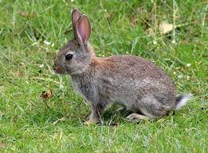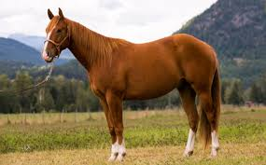

A horse is big. A rabbit is small.

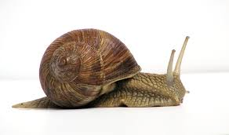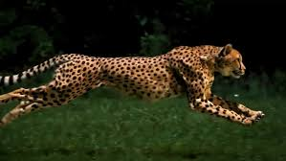

A cheetah is fast. A snail is slow.

Activities! You are welcome to do all of these activities but please do at least three of them.

1. Have your child choose 2 words that are opposite (big/small or fast/slow) and list animals that can go under each word.
2. Have your child choose three animals and have them write each one out 4 times each.
3. Have your child choose 2 animals and write 3 difference they have from each other.
4. Have your child practice these simple sight words 5 times each (us, around, found, which, made). This means to say the word, have the child say the word, and write the word.